Advanced Games Programming
CGP600 – AE1
James coyle – q13068296
Sean Khanna – Q11279516
2018
Contents
2 Documentation, Analysis and Design 2
2.1 Game idea 2
2.2 Using the requirements 3
2.3 Advanced features 3
2.4 Transferable techniques and Further learning 3
2.5 Problems 3
3 Task Breakdown and Rational 4
3.1 Tasks 4
3.2 Allocating tasks 4
4 Critical Discussion of Group Work 4
5 References 5
6 Appendix 0
6.1 Appendix A – Derived Tasks 0
6.1.1 Game Requirements 0
6.2 Appendix B – User Stories 0
6.2.1 Simple 0
6.2.2 Advanced 0
6.3 Appendix C – WBS 1
6.4 Appendix D – Pseudocode 2
6.4.1 Overarching Pseudocode 2
6.4.2 Settings [A] 3
6.4.3 Quit Game [B] 4
6.4.4 High Scores [C] 4
6.4.5 Fire [D] 4
6.4.6 Movement [E] 4
6.4.7 Pause Menu [F] 5
6.4.8 Collision Detection [G] 5
6.4.9 Death [H] 5
6.4.10 Win [J] 5
6.4.11 Clean-Up [K] 5
6.4.12 Loss [L] 6
6.5 Appendix E – Flow Charts 7
6.5.1 Overarching Game Flow Chart 7
6.5.2 Settings Flow Chart [A] 8
6.5.3 Quit Game Flow Chart [B] 9
6.5.4 High Scores Flow Chart [C] 10
6.5.5 Fire Flow Chart [D] 11
6.5.6 Movement Flow Chart [E] 12
6.5.7 Pause Menu Flow Chart [F] 13
6.5.8 Collision Detection Flow Chart [G] 14
6.5.9 Death Flow Chart [H] 15
6.5.10 Win Flow Chart [J] 16
6.5.11 Clean-Up Flow Chart [K] 17
6.5.12 Loss Flow Chart [L] 18
6.6 Appendix F – Class Diagrams 19
6.6.1 Version 1 19
6.6.2 Version 2 19
6.7 Appendix I – Testing Plans 20
6.7.1 Introduction 20
6.7.2 Objectives 20
6.7.3 Dependencies & Risks 20
6.7.4 General Risks 21
6.7.5 Pass/Fail Criteria 21
6.7.6 Results Documentation 22
6.8 Appendix K – Schedules 23
6.9 Appendix L – Equations 24
6.9.1 Equations Research 24
6.10 Appendix M – Risk Analysis 25
6.10.1 Task Risks 25
6.10.2 Risk Analysis Severity and Likelihood Table 26
6.11 Appendix N – Design Theme 27

Documentation, Analysis and Design

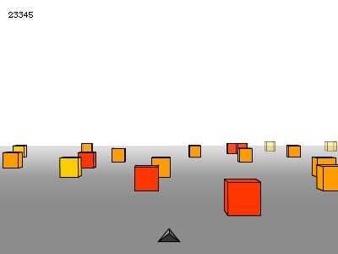
Game idea
For our game we have decided to create space shooting game (See Appendix N). Before we came up with idea, we did a little research into some games. I remembered when I was younger I used to play a game called cube runner. In this game you play as a 3D triangle and you try to dodge cubes by strafing left to right. This was a starting point for us, from here we went on to look at space type games like Fractured Space. We began to like this idea of free roaming in a 3D environment and a very good example of this type of free roaming in space is No Man Sky. In this game it allows the player to fully free roam around a procedurally generated map. These games gave us the basis of what we wanted to do with our game. After we created our final game design theme(See Appendix N) we decided to begin looking through the core requirements list.

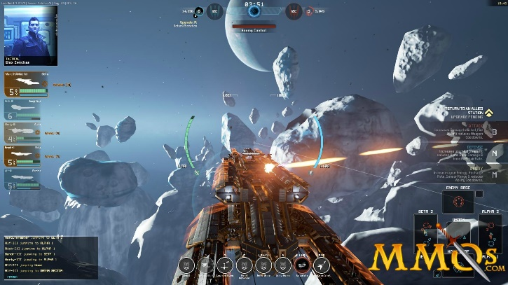
Giant Bomb, 2008. Cube runner.

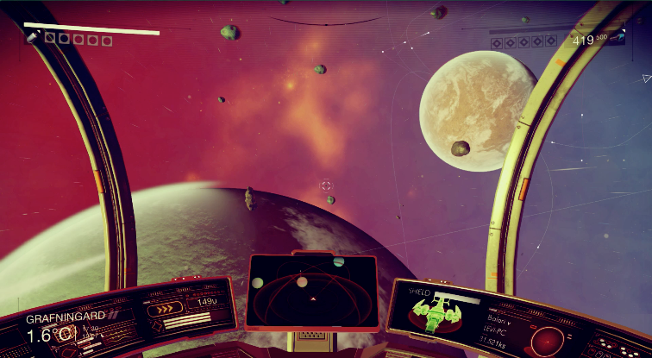

MMOs, 2015. Fractured Space.

Nerdist, 2016. No Man’s Sky.

Using the requirements
After fully analysing what the requirement list asked for, I created a very basic set of class diagrams using the current knowledge I had about the game (See Appendix F 6.6.1.). As you can see there are no methods and variables etc, because we were not 100% sure what tasks needed to be done. Therefore, I began to create a long list of user stories based off the core requirements and include some of my own advanced requirements that I know we are capable of achieving (See Appendix B). Once I completed the list, I was able to breakdown each task and start to create a 100% rule WBS (See Appendix C). Alongside this James was able to begin creating the flow charts (See Appendix E) and pseudocode(See Appendix D), to help us better understand how we would accomplish each task within our code. It also meant you can clearly see step-by-step the process of each method explained. Furthermore, I was then able to create a Gantt chart (see Appendix K) to see how each task would fit in with our limited timeline.
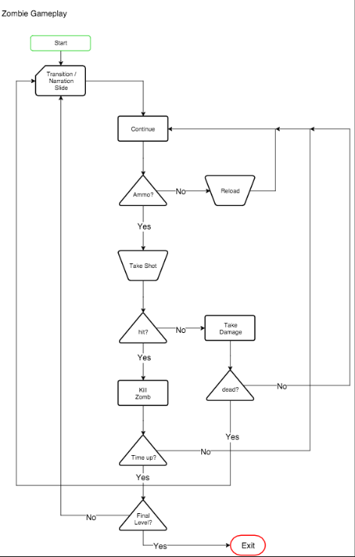
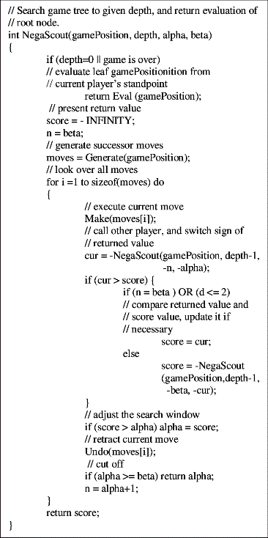
After completing some of these design tasks, I was then able to go back and create a second set class diagrams that was more detailed than its predecessor (see Appendix F 6.6.2.). Within these class diagrams I was able to include some methods and variables created from the user stories e.g. shooting (See Appendix B). These class diagrams were very easily connected to our list of pseudocode and flow diagrams (See Appendix D and Appendix E), further defining how the game will be created and play out. I find that using flow charts is much easier than pseudocode but not just for me, for clients also, like Edraw (2018) explains “…the tool's ability to visualize multiple progresses and their sequence into a single document.”, it makes the methods easier to read and understand. However, flowcharts might not be able to fully explain in one flowchart, a complex concept. Additionally, if we ever need to update or modify any flowcharts we may need to re-draw the whole diagram which can be very costly. On the other hand, pseudocode can be easily modified, if needs be. Moreover, it is extremely easy to convert into computer language (SOLARRENOVATE, 2018) but, it can be time consuming if very complex. Unfortunately, depending on who reads it, some people might not be able to easily follow what is happing within the pseudocode because of its intricacy.
Pseudocode, ResearchGate, 2014.
Flowcharts, Game Development, 2016.

Advanced features
In the past, we have had to create a game were you used a technique called procedural generation, which is “…the creation of content according to the parameters of an algorithm…” (Joel Lee, 2014). Within our game we have decided to incorporate this as an additional feature, we plan to have our asteroids procedurally create themselves as the player traverses around the map.

Transferable techniques and Further learning
Fortunately, from previous units I have learned a lot of techniques that I can use inside this project for example, threads. Threads allow me to do multiple things at the same time like, playing sounds or music, instead of it having to pause the game and ruining the user experience.
As you can see from the user stories and the task list created from it, I have decided that I want to try harder and more complex shaders. In class, we learn about two types of shaders, the vertex shader and the pixel shader. However, these are not the only shaders. After doing some research I found another shader called tessellation shader, which can be used with both OpenGL 4.0 and Direct3D 11. I have learnt from Microsoft (2018) that, using tessellation can save on memory allowing higher quality surfaces to be displayed on lower resolutions. Within this project I have planned to push myself to use more complicated techniques such as this, so that I will have a larger knowledge base in this topic.

Problems
As we designed this project we found lots of problems, mainly due to the fact we have not learnt how implement certain techniques like lighting. This led to some issues in creating flow charts, class diagrams and Gantt charts etc., making it very difficult to plan our time accordingly (See Appendix K). Nevertheless, we have planned for this and have created a risk analysis to highlight all possible risks, their likelihood and severity and then creating a table to show it (See Appendix M).

Task Breakdown and Rational

Tasks
So, to begin breaking down the tasks I wrote up a set of user stories from simple stuff to advanced stuff (See Appendix B). Future Of CIO (2014) explains user stories to be very beneficial by saying “high-level user stories are the way to go and lend themselves better to planning sessions and introducing detailed functionality at the last possible minute”. These included stories I believed the client, stakeholder, player and programmer would want to have within the game. Each user story led to a new derived task (See Appendix A), in the end we had 13 simple tasks that meet the core requirements of the game, like I said before I know we are capable of achieving this and more so I extended the amount of user stories and derived tasks to a point at which I felt that, it would no longer be achievable, this extra list consists of nine reachable tasks. All of which, have been fully documented within the WBS and Gantt chart.

Allocating tasks
Allocating tasks was fairly easy for James and me because, over the numerous years we have done multiple group projects together, been out for many social occasions etc. and learned about each of our strengths and weaknesses. However, this didn’t mean we would choose a task that best suited us, purely for the fact that we both wanted to try out new techniques and programs. Therefore, after we had defined the tasks we split them evenly between us giving each of us new types of task that we would normally not do. For example, in the past I would normally look after things like the flow charts, pseudocode and class diagrams but, I would usually leave Gantt charts and risk analysis to James. This time around we decided on swapping a few tasks, I created the Gantt charts and WBS which was out of my comfort zone. However, I did not regret doing it, as I have now learned so much about how Gantt charts work and how they show the work load spread out and features such as the critical path. James, on other hand, created the flow charts, pseudocode and test plans, also to make sure the work load was balanced and had good rationale we decided to not only have our own tasks but also work together on some of them like the risk analysis (See Appendix M). This task rotation taught both me and James lots of new things but like Robert Half (2016) explains “Job rotation accelerates professional development”. Then again, Rachel Blackely-Gray (2017) say that we “Could end up with disgruntled employees”. Fortunately, I believe that this didn’t happen for us and that we actually learned a lot and if not made us a better working team.

Critical Discussion of Group Work

- Strengths
- Weaknesses
- Methods, benefits and constraints of group work in the design process.
Each group member should individually reflect on the group work that has been done, including the processes used, problems encountered and solutions found. Some discussion of strengths, weaknesses and improvements that could be made to the process should be considered.
CRITERIA | A1 – A4 | B1 – B3 | C1 – C3 | D1 – D3 | F1 – F3
CRITICAL DISCUSSION OF GROUP WORK  (learning outcomes C2)  (10%) | A thorough and detailed reflection on the group work design process with detailed explanation of what problems occurred and how they were or could have been resolved. | Detailed evidence of reflection on the group work design process, including what has been learnt and what improvements could be made | Evidence of reflection on the group work design process, including valid strengths and weaknesses. | Some evidence of reflection on the group work design process. May be brief or unclear in parts | Inaccurate and/or largely incomplete reflection of the group work design process.

References
Giant Bomb, 2008. Cube runner [viewed 28/10/2018]. Available from: https://www.giantbomb.com/cube-runner/3030-21890/
Nerdist, 2016. EVERYTHING YOU NEED TO KNOW ABOUT NO MAN’S SKY [viewed 28/10/2018]. Available from: https://nerdist.com/no-mans-sky-7-things-you-didnt-know/
MMOs, 2015. FRACTURED SPACE [viewed 28/10/2018]. Available from: https://mmos.com/review/fractured-space
Edraw, 2018. Top Benefits of Flowchart [viewed 29/10/2018]. Available from: https://www.edrawsoft.com/flowchart-benefits.php
SOLARRENOVATE, 2018. WHAT IS PSEUDOCODE – ADVANTAGES AND DISADVANTAGES OF PSEUDOCODE, [viewed 29/10/2018]. Available from: https://solarrenovate.com/pseudocode-advantages-disadvantages-pseudocode/
StackExchange, 2016. Game Development [viewed 29/10/2018]. Available from: https://gamedev.stackexchange.com/questions/114559/is-flowchart-correct-way-to-visualize-gameplay
ResearchGate, 2014. A Comparative Study of Game Tree Searching Methods [viewed 29/10/2018]. Available from: https://www.researchgate.net/figure/NegaScout-Algorithm-Pseudo-Code-Using-the-Minimal-Window-Search-Principle_fig5_262672371
Microsoft, 2018. Tessellation Stages [viewed 29/10/2018]. Available from: https://docs.microsoft.com/en-us/windows/desktop/direct3d11/direct3d-11-advanced-stages-tessellation
Joel Lee, 2014. How Procedural Generation Took Over The Gaming Industry [viewed 29/10/2018]. Available from: https://www.makeuseof.com/tag/procedural-generation-took-gaming-industry/
Robert Half, 2016. Job Rotation for Your Staff: Why Letting Go Could Mean Holding On [viewed 29/10/2018]. Available from: https://www.roberthalf.com/blog/management-tips/job-rotation-for-your-staff-why-letting-go-could-mean-holding-on
Pearl Zhu, 2014. Agile Clarity: Use Stories vs. User Cases [viewed 29/10/2018]. Available from: http://futureofcio.blogspot.com/2014/01/agile-clarity-use-cases-vs-user-stories.html
Rachel Blakely-Gray, 2017. 5 Advantages and Disadvantages of a Job Rotation Program [viewed 29/10/2018]. Available from: https://www.patriotsoftware.com/payroll/training/blog/5-advantages-disadvantages-job-rotation-strategy/

Appendix

Appendix A – Derived Tasks

Game Requirements

Simple WBS Reference
- 3rd person Camera 2.2.1.
- Player is a spaceship 2.4.
- Movement 2.4.1.
- Shooting 2.4.2.
- Lighting 2.3.
- Procedural generated asteroids with own trajectory 2.6.2.
- Enemies with AI 2.5.1.
- Collision detection 2.4.3.
- Simple Shader 2.4.4.
- Physics
- Textures 2.12.
- Skybox 2.13.
- Score 2.11.

Advanced
- Sounds and music 2.7.
- Advanced shader techs 2.10.
- Settings 2.9.
- Shadow mapping 2.8.
- Dialog Boxes 2.14.
- 1st person camera option 2.2.2.
- Advanced particle effects 2.4.5. & 2.5.2.
- Custom Font 2.15.
- Currency 2.16.
Appendix created by Sean Khanna

Appendix B – User Stories

Simple
As a player I want to be able to see my ship so that I can see what my ship looks like.
As a player I can fly around in a ship because it’s a space game.
As a player I want to be able to move around the scene so that I can explore the map.
As a player I want to be able to shoot my enemies so that they don’t kill me first.
As a stakeholder I want there to be lighting effects so that the game has more personality.
As a programming I want to procedurally generate asteroids with their own trajectory because I want players to always be on their toes trying to avoid asteroids.
As a client I want to be able to see Enemies chase the player because it will make the game more immersive.
As a user I want to have good collision with walls etc. because I don’t want to be able to see in side boxes or be able to walk through walls.
As a programmer I want to use shaders because I want the characters to have shades against asteroids.
As a programmer I want my asteroids to have physics applied to them because it will give a good effect when a player collides with them and they, fly away.
As a programmer I want to apply textures to all my objects because I don’t want my objects to look boring.
As a programmer I want to use a skybox because it will help with to optimise my game.
As a programmer I want a camera because I want the player to be able to see the game.
As a player I want to have a score element because I want to be able to have a sense of achievement.

Advanced
As a programmer I want to include sounds and music because I want the player to have another feedback source apart from visual.
As a programmer I want to use advanced shader techniques because I want to test my skills and create better looking models.
As a user I want to have a settings menu because I want to be able to adjust some settings for example screen size, volume or key bindings etc.
As a programmer I want to have shadows because my objects to have a more realistic feel to them.
As a client I want to have dialog boxes because I want the game to have a story to go with them.
As a programmer I want to give an option for the player to be able to switch the camera position because it will allow the player to play the game from a different perspective for example, first person or third person and be able to see the ship’s skins.
As a programmer I want to have particle effects because I want the player to know when the ships are moving visually.
As a client I want fonts that match the theme because I don’t want a miss match of styles.
As a player I want to have currency because I want to be able to upgrade my ship or buy new skins.
Appendix created by Sean Khanna

Appendix C – WBS
Appendix created by Sean Khanna

Appendix D – Pseudocode

Overarching Pseudocode
Call LoadSaveGame
Initialise Renderer
Initialise Direct3D
Initialise Game Manager
Initialise Physics
Initialise Sound Manager
Initialise Texture Loader
Initialise Text
Initialise Lighting
Load Direct3D 3D models and render to scene
Ship
Asteroid
SkyBox
Load SFX & Music files into memory

Set GameRunning bool to false

Render scene to screen

Draw buttons to screen
Play button
Settings button
Quit button

Window Input
Switch
Player pressed settings button?
Display settings
Player pressed quit button?
Clean-Up
Exit program
Player pressed high scores button?
Display high scores
Player pressed play button?
Set coordinates of objects to save game data
Set GameRunning bool to true
End switch
Loop

Input thread
Input loop
Did the player press the fire button?
Fire projectile
Did the player move the mouse/joystick?
Move the player
Did the player press escape?
Set GameRunning to false
Activate pause menu
Did the player defeat all enemies?
Display win screen
Did the player die?
Display loss screen
Loop

AI thread
Is there an enemy within X distance?
Is there an enemy within max shooting distance?
Move into range of enemy
Is an enemy in line of fire of the AI’s turrets?
Turn to face enemy
Are the weapons off cooldown?
Fire the weapons
Has the enemy died?
Activate entity died routine
Has the win condition been met?
Clean-up

Physics thread
For each object
Check for collisions
Perform calculations to check for collisions before moving
Move object if collisions aren’t going to happen
Apply angular velocity to all objects
loop

Sound thread
Sound loop
Are sounds currently playing?
Continue playing
Is a new sound required?
Play sound
Is GameRunning false?
Pause all sounds
Is the game win condition met?
Clean-up
loop

Main game loop
Is player dead?
Display loss screen
Close program
loop

LoadSaveGame function
Start
Open save file for reading
Do until end of file
Read Save #N (Coords: X, Y, Z, Rotation: X, Y, Z)
For each object
Read Save #N (Coords: X, Y, Z, Rotation: X, Y, Z)
loop
loop
Close save file
End

Settings [A]
For each main menu button
Is the button visible?
Hide button
Loop

For each settings control
Is the button invisible?
Unhide button
Loop

Input player loop
Did the player press the increase SFX volume button?
Is the SFX volume not 100?
Sound -> increase SFX volume
Did the player press the decrease SFX volume button?
Is the SFX volume above 0?
Sound -> decrease SFX volume
Did the player press the increase music volume button?
Is the music volume not 100?
Sound -> increase music volume
Did the player press the decrease music volume button?
Is the music above 0?
Sound -> decrease music volume
Did the press the fullscreen/windowed toggle button?
Is the window windowed?
Call direct3d change screen setting function (fullscreen)
Is the window fullscreen?
Call direct3d change screen setting function (windowed)
Did the player press the escape key or back button?
For each settings button
Hide button
loop
for each main menu button
unhide button
loop
exit loop
loop

Quit Game [B]
Is there a save file already saved in the default location?
Open the text file for editing
Save Player coordinates (Location: X, Y, Z, Rotation: X, Y, Z)
Save object coordinates (Location: X, Y, Z, Rotation: X, Y, Z)
Close text file
Is there no save file in the default location?
Open new text file for editing
Save Player coordinates (Location: X, Y, Z, Rotation: X, Y, Z)
Save object coordinates (Location: X, Y, Z, Rotation: X, Y, Z)
Close text file

Call clean-up function

High Scores [C]
For each main menu button
Hide button
Loop
For each high scores button
Unhide button
Loop
Open hide scores text file for editing
Do until eof
Get Score & Player name
Loop
For i = lower bound of score & name array to upper bound of array
Sort from highest to lowest, giving a rank number
Next i
Display list of high scores onto screen
Close high scores text file

Fire [D]
Is the cooldown bool false for the entities weapon?
Particle system -> Set projectile to visible
Particle system -> Move projectile to turret end
Particle system -> Set forward velocity and rotation of projectile
Set the cooldown bool to true
Set the cooldown time to current time plus X seconds

Each frame
Advance projectile forward by velocity amount
Has the object collided with something?
Is the collision against an enemy?
Apply damage to the enemy entity
Is the enemy dead?
Add to score
Play death animation
Play death sound
Is the enemy alive?
AI -> Received damage function
Is the collision not against an enemy?
Set projectile velocity to 0
Return projectile to starting location
Hide the projectile
Has the object not collided?
Has the projectile reached the distance limit?
Set projectile velocity to 0
Return projectile to starting location
Hide the projectile

Next frame

Movement [E]
Input -> get new mouse coordinates
Camera.rotation.x, y & z = Input.Mouse.x, y & z
Is the player pressing the accelerate key?
Is the player at peak velocity?
Keep velocity as it is
Move entity (and check collision [G])
Is the player under peak velocity?
Velocity += speed
Move entity (and check collision [G])
Is the player pressing the brake key?
Is the player moving?
Velocity -= braking
Move entity (and check collision [G])
Is the player still?
Maintain 0 velocity

Pause Menu [F]
Set GameRunning to false
for each pause menu graphic
unhide graphic
loop
get input loop
did the player click the quit button?
Quit Game [B]
Did the player click the resume button?
For each pause menu graphic
Hide graphic
loop
Set GameRunning to true
Exit loop
Loop

Collision Detection [G]
Is there an object within a certain radius of our object (within collision distance)?
For each quarter of each model
Is the collide able object in the vicinity?
For each vertex in our model
Did the vertex collide with the object?
Apply collision damage and send message upwards to collided object
Move entities to last position of no collision and reverse direction & velocity
Was the entity controlled by AI?
AI -> Notify of collision
Play collision sound effects for both entities
Play collision animation for both entities
loop
loop

Death [H]
Particle system -> spawn explosion particles
Play death sound effect
Play death animation
Set IsCollideable to false
Particle system -> remove explosion particles (clean-up)
Trigger on-death function call
Unload the entity from memory

Win [J]
Set GameRunning to false
For each in-game ui element
Hide element
Loop
For each victory element
Unhide element
Loop
Get player input
Did the player press the quit button?
Close application
Did the player press the high scores button?
Display high scores menu [C]
Did the player press the play button?
Reset game
Set GameRunning to true
Loop

Clean-Up [K]
For each rendering asset
Set to nothing
Loop
For each sound asset
Set to nothing
Loop
Set all class objects to nothing in reverse order of when they were created
Physics, Sound, Input & AI -> Join threads to main thread
Close program

Loss [L]
Set GameRunning to false
For each in-game ui element
Hide element
Loop
For each loss screen element
Unhide element
Loop
Get player input
Did the player press the quit button?
Close application
Did the player press the high scores button?
Display high scores menu [C]
Did the player press the play button?
Reset game
Set GameRunning to true
Loop

Appendix created by James Coyle

Appendix E – Flow Charts

Overarching Game Flow Chart

Settings Flow Chart [A]

Quit Game Flow Chart [B]

High Scores Flow Chart [C]

Fire Flow Chart [D]

Movement Flow Chart [E]

Pause Menu Flow Chart [F]

Collision Detection Flow Chart [G]

Death Flow Chart [H]

Win Flow Chart [J]

Clean-Up Flow Chart [K]

Loss Flow Chart [L]
Appendix created by James Coyle

Appendix F – Class Diagrams

Version 1

Version 2
Appendix created by Sean Khanna

Appendix I – Testing Plans

Introduction

Goals
The goal for this test plan is to thoroughly test the resulting project’s software production to check consistency, balancing and for any errors.

Scope
The test plan will cover all code written, there are no requirements to test any part of the graphical elements of the end software product. The test plan will not test things like user feedback because ultimately there are currently no plans for the project to reach the public.

Schedule

Ad-Hoc
Ad-Hoc testing will be conducted throughout the software development process (being superseded by White and Black box testing at the end of the development cycle, therefore the schedule for ad-hoc testing is unknown and depends heavily on the situation.

White Box
White box testing will comprise 75% of the time allocated to software testing, this will provide an adequate chance to document any known bugs and fix them before release.

Black Box
Black box testing will comprise the remaining 25% of the allocated software testing time (seen in the project Gantt chart), the reason for this is that black box testing won’t cover quite as much as White box and is more a “surface” check to ensure everything is working fine on the consumers side.

Objectives

Ad-hoc
To test all code/software developed or applicable to the end software before release, this will happen during development.

White Box
- Test all interactions between entities to ensure algorithms/interactions are performed correctly
- Test Initial setup values to ensure everything is initialised correctly
- Test Direct3D functions output to ensure correct models/graphics/sounds are being set correctly
- Test threading for each sub-process (see overarching flow diagram)
- Test functions with mock data to ensure all output/errors are process correctly/caught (below min, min, average, max, above max, obscure)

Black Box
- Check graphics are loaded & displayed correctly in general
- Test movement controls
- Test collisions
- Check UI/UX for errors
- Test sounds
- Test win/lose
- Test High scores

Dependencies & Risks

Microsoft (GitHub)
- GitHub goes down
- Microsoft shut GitHub down
- Data is leaked and data protection laws are broken
- Files are lost

Microsoft (Word)
- Microsoft Word crashes and corrupts the test results file resulting in a complete restart being required

Microsoft (Visual Studio)
- A patch is released which corrupts files, resulting in a complete restart
- File not saved correctly, resulting in lost work
- Microsoft stops its free software program

Microsoft (DirectX)
- An error in DirectX results in skewed test results
- Direct3D version is updated, and everything changes, resulting In the requirement to re-learn the language used

General Risks
- Software product released without adequate testing, resulting in errors for the end user
- Not enough time to test everything to the level of detail expected
- Things like sickness/family issues which prevent full testing being completed
- Function testing not done correctly, and errors are released with the product
- White Box testing reveals massive issues with the programs core functionality which Ad-Hoc testing didn’t reveal

Pass/Fail Criteria

Ad-Hoc
As there are no clearly defined criteria for this type of testing (the tests are so varied and random that the criteria would cover literally everything in the other two types).

White Box

Type of Test
- Function Testing
  - Minimum
  - Below Minimum
  - Average/Normal
  - Maximum
  - Above Maximum
  - Obscure Value
- Class Testing
  - Initialisation
  - Variable/Function Availability
  - Inheritance
  - Polymorphism
  - Overloading

Pass Criteria
- Function Testing
  - The minimum value is entered into the function and the function provides correct response/output.
  - Below the minimum value is entered into the function and the function throws an error/returns correctly incorrect response.
  - The Average/Normal value is entered into the function and the function provides correct response/output.
  - The maximum value is entered into the function and the function provides correct response/output.
  - Above the maximum value is entered into the function and the function throws an error/returns correctly incorrect response.
  - An obscure value is entered into the function and the function deals with this obscure value correctly without returning/providing an incorrect response or output.
- Class Testing
  - Initialisation sets the class up in the desired setting.
  - Each function call or variable use is available/restricted depending on design specification.
  - Inheritance for the class is setup correctly and child classes can access all relevant functions/variables of their parents.
  - Functions accept required polymorphed variable parameters.
  - Any overloads written output correctly when using controlled tests

Black Box

Type of Test
- Movement testing
- Screen size testing
- UI/UX testing
- Shooting test
- Collision testing
  - Moving object
  - Unmoving object
- Win/Loss tests
- High scores test
- Quit game test

Pass Criteria
- Moving the controls moves the player’s ship
- Resizing using the options menu sets the game to fullscreen/windowed
- UI is coherent and scales to screen size
- Projectiles shoot when pressing the fire button, projectiles visibly travel towards target and if hit do damage
- Collision testing
  - Collision with the object makes both objects bounce off of each other (as well as plays sound effects and/or animation)
  - Collision with the object makes the player ship bounce off of the unmoving object
- Winning the game displayed the win screen, with appropriate play again/high scores/quit buttons, similarly losing the game displays the loss screen, with the same buttons
- High scores are in order and seem to work correctly when testing the game consistently
- Quitting the game at any point doesn’t break the program

Results Documentation
The results of the test phase of the project will be culminated in a final document which has a grid of: Type of Test (White, Black, Ad-Hoc), Test performed, Expected result, Actual Outcome, Pass/Fail, Screenshot, Fix (In brief). This will give us the required results in an easily viewable format with little to go wrong.
Appendix created by James Coyle

Appendix K – Schedules
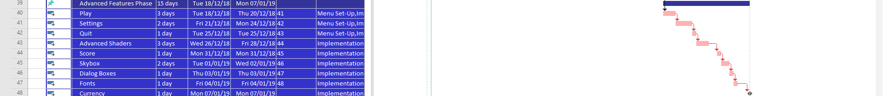
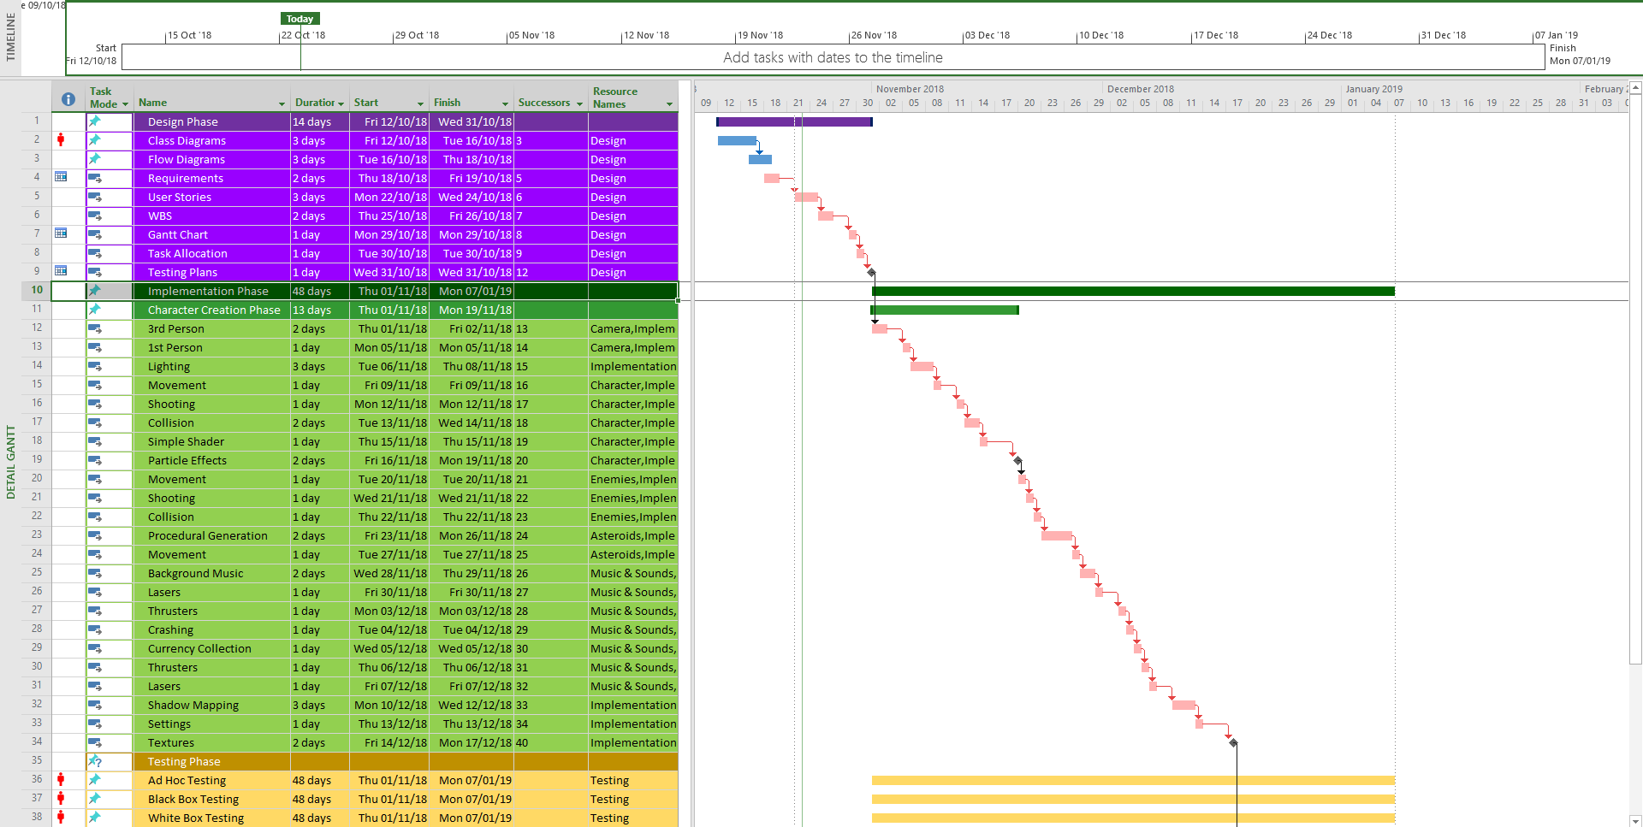

Appendix created by Sean Khanna

Appendix L – Equations

Equations Research

Matrices

Identity Matrix
$I=\left[\begin{matrix}1 & 0 & 0 & 0 \\ 0 & 1 & 0 & 0 \\ 0 & 0 & 1 & 0 \\ 0 & 0 & 0 & 1\end{matrix}\right]$

Scale
$M=S\left[\begin{matrix}1 & 0 & 0 & 0 \\ 0 & 1 & 0 & 0 \\ 0 & 0 & 1 & 0 \\ 0 & 0 & 0 & 1\end{matrix}\right]= \left[\begin{matrix}S×1 & S×0 & S×0 & 0 \\ S×0 & S×1 & S×0 & 0 \\ S×0 & S×0 & S×1 & 0 \\ 0 & 0 & 0 & 1\end{matrix}\right]= \left[\begin{matrix}S & 0 & 0 & 0 \\ 0 & S & 0 & 0 \\ 0 & 0 & S & 0 \\ 0 & 0 & 0 & 1\end{matrix}\right]$

Rotation
$$R_{x}= \left[\begin{matrix}1 & 0 & 0 & 0 \\ 0 & cosθ & -sinθ & 0 \\ 0 & sinθ & cosθ & 0 \\ 0 & 0 & 0 & 1\end{matrix}\right]$$
$$R_{y}= \left[\begin{matrix}cosθ & 0 & sinθ & 0 \\ 0 & 1 & 0 & 0 \\ -sinθ & 0 & cosθ & 0 \\ 0 & 0 & 0 & 1\end{matrix}\right]$$
$$R_{z}= \left[\begin{matrix}cosθ & -sinθ & 0 & 0 \\ sinθ & cosθ & 0 & 0 \\ 0 & 0 & 1 & 0 \\ 0 & 0 & 0 & 1\end{matrix}\right]$$

Translation
$$T= \left[\begin{matrix}1 & 0 & 0 & x \\ 0 & 1 & 0 & y \\ 0 & 0 & 1 & z \\ 0 & 0 & 0 & 1\end{matrix}\right]=\left[\begin{matrix}1+x \\ 1+y \\ 1+z \\ 1\end{matrix}\right]$$
Were $θ$ is the value of the angle to rotate (converted from degrees to radians).

Dot Product
$$a∙b=a_{x}b_{x}+a_{y}b_{y}+a_{z}b_{z}$$

Cross Product
$$v_{1}×v_{2}=v_{3}$$
$$v_{3}=\left(y_{1}×z_{2}\right)-\left(z_{1}×y_{2}\right),\left(z_{1}×x_{2}\right)-\left(x_{1}×z_{2}\right),\left(x_{1}×y_{2}\right)-(y_{1}×x_{2})$$

Collision Detection
$$Distance=\sqrt{{(x_{2}-x_{1})}^{2}+{(y_{2}-y_{1})}^{2}+{(z_{2}-z_{1})}^{2}}$$
If $(\left({radius}_{1}+{radius}_{2}\right)>Distance)$ then collision.
Appendix Created by Sean Khanna and James Coyle

Appendix M – Risk Analysis

Task Risks
Task | Risk | Solution
Flow diagrams | The flow of each chart could be incorrect as our knowledge base of DirectX is limited. | Extensive research into unknown areas e.g. labs, internet and books.
Requirements | Don’t know if all requirements are achievable before deadlines. | Adding additional implementation phase for advanced tasks
User stories | Missed some stories, due to lack of communication with target audience. | Collect more information from users, clients, stakeholders and programmers.
WBS | Unknown amount of workload and time needed to complete each task. | Research into how to estimate, different task workloads and time management estimations.
Gantt chart | Relies heavily on WBS and user stories to be correct. | Research into how to estimate, different task workloads and time management estimations.
Testing plan | Will not fully cover everything to be tested in the final release. | Ensure full testing is completed at the end via adequate time management.
Menu setup | Buttons don’t perform correctly. | Test.
Cameras | Loads every object within the game, leading to slow performance. | Implement code that only allows objects in view to be rendered. (Unknown solution)
Lighting | No knowledge base. | Research from labs, internet and books.(Unknown solution)
 | Graphical errors. | Unknown solution.
Character Creation | Model doesn’t fit the purpose of original design. | More research into the models to get a better model.(Unknown solution)
 | Controls don’t work correctly. | Test.
 | Collision detection. | Test.
Enemies | AI is too easy/hard to play against. | Test then balance skill level.
 | Collision. | Test.
 | Damage equation is unbalanced. | Test then balance.
Asteroids | Algorithm procedurally spawns them incorrectly. | Test.
 | Collision detection. | Test.
Sounds & Music | Pauses game. | Set up threads correctly.
 | Plays incorrect sound/SFX. | Test.
Shadow Mapping | Incorrect shadow placement. | Test. (Unknown solution)
 | No knowledge base. | Research from labs, internet and books. (Unknown solution)
Settings | Changing screen size might stretch images. | Test.
 | Sound/SFX controls work incorrectly. | Test. (Unknown solution)
Advanced Shaders | No knowledge base. | Research from labs, internet and books. (Unknown solution)
Score | Doesn’t save correctly. | Test.
Textures | Don’t load correctly. | Test. (Unknown solution)
 | Bump maps don’t work. | Test. (Unknown solution)
Skybox | Textures too big. | Compress and test different versions. (Unknown solution)
Dialog boxes | Alignment incorrect. | Test. (Unknown solution)
 | Font size too big/small. | Test. (Unknown solution)
Fonts | Fonts pixilated. | Get font letter sizes, then set the container size to be the same size as all of the letters combined. (Unknown solution)
Currency | Money balancing. | Black box test then balance.
Appendix Created by Sean Khanna and James Coyle

Risk Analysis Severity and Likelihood Table
 |  | Severity
 |  | 1 | 2 | 3
Likelihood | 1 | - Requirements - Don’t know if all requirements are achievable before deadlines. - Adding additional implementation phase for advanced tasks  - Character Creation - Model doesn’t fit the purpose of original design. - More research into the models to get a better model. (Unknown solution)  - Enemies - Damage equation is unbalanced. - Test then balance.  - Sounds & Music-Plays incorrect sound/SFX.-Test.  - Score - Doesn’t save correctly. - Test.  - Dialog boxes - Font size too big/small. - Test. (Unknown solution)  - Currency - Money balancing. - Black box test then balance. | - Skybox - Textures too big. - Compress and test different versions. (Unknown solution)  - Character Creation - Controls don’t work correctly. - Test.  - Enemies-AI is too easy/hard to play against. - Test then balance skill level.
Likelihood | 2 | - User stories - Missed some stories, due to lack of communication with target audience. - Collect more information from users, clients, stakeholders and programmers.  - Fonts - Fonts pixilated. - Get font letter sizes, then set the container size to be the same size as all of the letters combined. (Unknown solution) | - Textures - Don’t load correctly. - Test. (Unknown solution)  - Dialog boxes - Alignment incorrect. - Test. (Unknown solution) | - Testing plan - Will not fully cover everything to be tested in the final release. - Ensure full testing is completed at the end via adequate time management.  - Lighting - Graphical errors. - Unknown solution.  - Asteroids - Algorithm procedurally spawns them incorrectly. -Test.  - Settings - Changing screen size might stretch images. - Test.  - Settings - Sound/SFX controls work incorrectly. - Test. (Unknown solution)
Likelihood | 3 | - Flow diagrams - The flow of each chart could be incorrect as our knowledge base of DirectX is limited. - Extensive research into unknown areas e.g. labs, internet and books.  - WBS - Unknown amount of workload and time needed to complete each task. - Research into how to estimate, different task workloads and time management estimations.  - Gantt chart - Relies heavily on WBS and user stories to be correct. - Research into how to estimate, different task workloads and time management estimations.  - Menu setup - Buttons don’t perform correctly. - Test.  - Shadow Mapping - Incorrect shadow placement. - Test. (Unknown solution)  - Advanced Shaders - No knowledge base. - Research from labs, internet and books. (Unknown solution)  - Textures - Bump maps don’t work. - Test. (Unknown solution) | - Character Creation - Collision detection. - Test.  - Enemies - Collision. - Test.  - Sounds & Music - Pauses game. - Set up threads correctly.  - Shadow Mapping - No knowledge base. - Research from labs, internet and books. (Unknown solution) | - Cameras - Loads every object within the game, leading to slow performance. - Implement code that only allows objects in view to be rendered. (Unknown solution)  - Lighting - No knowledge base. - Research from labs, internet and books. (Unknown solution)  - Asteroids - Collision detection. - Test.
Appendix Created by Sean Khanna and James Coyle

Appendix N – Design Theme
The design theme we chose to create was a space themed game were the player can free roam around a solar system. There are alien enemy ships which will try to kill you, it’s a score based game in which you gather score and currency by eliminating alien ships, while dodging asteroids. The further you get and more enemies you kill the higher your score.
Appendix created by James Coyle and Sean Khanna

